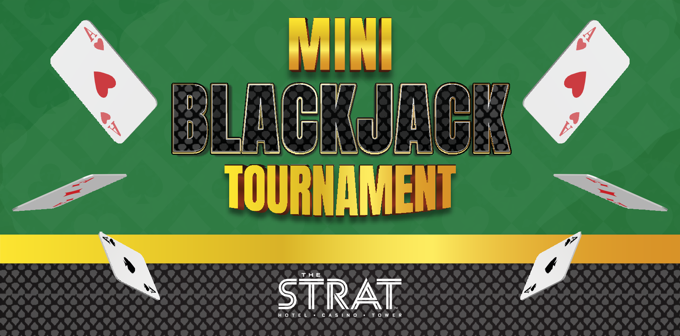MINI

**EVERY TUESDAY • 4PM-6PM**

Must be 21 or older. Gambling problem? Help is available. Call 1.800.GAMBLER

**$1,000 TUESDAY BLACKJACK TOURNAMENT RULES**

# TOURNAMENT DATES:

Every Tuesday, July 1-December 30, 2025, 4pm-6pm

# REGISTRATION:

Buy-in and Re-buys at the Cage the day of the tournament, 2pm – 5pm. Redeem buy-in receipt at Pit 2 on the casino floor.

**One-Time-Bet Promo Chip Prize Breakdown:**

1st - $500

2nd -$200

3rd - $100

4th - $100

5th - $100

# Who can participate?

Any guest who has a True Rewards card and paid the $25 buy-in fee are welcome to participate.

1. Players who buy-in for $25 will receive one entry.
2. Blackjack will be played with six (6) decks. All rounds will consist of ten (10) hands.
3. Tournament will consist of six 15-minute rounds with players entered on a first-come, first-served basis.
4. The top five (5) players between all eight (8) rounds will be awarded one-time bet promo chips based off their ranking, with the highest chip total winning 1st place, the second-highest chip total winning 2nd place, and so on.
5. A minimum of five (5) players will be required for the tournament to commence. Players may only win once per tournament.
6. $25 re-buys: Participants can re-buy into a later tournament round. Players may re-buy a maximum of two times per tournament for a total of three possible participating rounds. The player’s top round will be used when determining their chip total and not the cumulative total.

# Each player will receive $5,000 in tournament chips at the beginning of each round.

1. All tournament chips must remain in full view of the tournament judges at all times, and stacked in denominational order. Tournament chips may not be exchanged, borrowed or loaned between players. Failure to follow these rules may result in the disqualification and forfeiture of any prize money.
2. A rotating marker will be used indicating “1st base.” Player with the “high card” will be 1st base in hand 1.
3. The marker will move one position to the right after each hand is dealt.
4. All bets must be in multiples of $100 with a minimum bet of $500. No maximum wager.
5. Blackjack pays 2-1.
6. Even money bets are allowed. No insurance required on blackjack.
7. Players may play only one hand at a time and must play in the circle located directly in front of them.
8. When it is a player’s turn to bet, he/she will have approximately 30 seconds to bet, otherwise a $500 minimum bet will automatically be placed.
9. If a dealer deals cards out of order, and no one has acted upon their hand, all hands are dead, unless there is action and then it is up to the tournament officials’ ruling.
10. If a player has less than the minimum bet remaining, the player will automatically be eliminated from play.
11. All chips must be counted before round results become official.
12. The official tournament language is English and conversing in any other language will not be permitted.
13. Communication, either verbal or visual (e.g. signaling) will not be permitted between players and spectators. This may result in disqualification and forfeiture of any prize money.
14. No written or mechanical aids will be permitted.
15. The use of cell phones, smartphones, personal data assistants (“PDAs”) or other mobile devices (e.g., iPads, Kindles, calculators) during tournament play is prohibited.
16. All players must be in their seat by the start of their assigned round time.

# If a player is late to the table, the late player will automatically forfeit $500 per round for up to three (3) rounds. If the late player has not arrived by the beginning of the 4th round, that person will be disqualified from the tournament round.

1. Tournament participants will not be allowed to discuss betting strategy with other participants during the play. IT IS THE PLAYER’S RESPONSIBILITY TO COMMUNICATE HIS/HER ACTION TO THE DEALER.
2. In the event of a tie in which a prize-winning position is involved, the affected players will be placed in a bonus round to determine placement. This bonus round will only involve tied participants and will consist of $1,500 in tournament chips per player and three (3) hands of blackjack following these official tournament rules. Winning results will only be to determine placement amongst tied individuals and will not affect previous play, chip counts, or positions.
3. If all players bust out, there will be no prize money awarded. Similarly, if there are less than 5 players with chip counts at the end of their round, those players will place and receive a prize and the rest of the prizes will be forfeited.
4. Prizes are held available at the cage for up to seven (7) days after the tournament date. If they are not picked up prior to that they will be forfeited.
5. Any player who violates the official rules or becomes offensive to other players may be disqualified and subject to forfeiture of any prize money.
6. Participant must be 21 years or older and have a True Rewards card.
7. Spectators who draw attention to or comment on play or bets will be asked to leave the area of play.
8. Players must be in attendance when prizes are announced in order to collect winnings.
9. The STRAT tournament committee will not accept any private arrangements between tournament players, or the interchanging of sessions and/or seats. Tournament players may not arrange for substitute players.
10. All disputes must be handled at the tournament table before the players leave the table.
11. In the event of a dispute, the decision of the tournament committee will be final.
12. The STRAT’s house rules will prevail over any situation not covered in the tournament rules.
13. NO SMOKING OR VAPING WILL BE PERMITTED AT TABLES DURING TOURNAMENT PLAY.
14. Management reserves the right to make all final decisions regarding interpretation of rules and eligibility determinations for any promotion, subject to applicable laws and regulations.
15. Team members of Golden Entertainment, Inc.; Arizona Charlie’s Decatur; Arizona Charlie’s Boulder; The STRAT Hotel, Casino & Tower; Aquarius Casino Resort; Edgewater Casino Resort, Gold Town Casino, Lakeside Casino & RV Park, Pahrump Nugget and Golden Tavern Group, its successors and assignees of sponsors, its advertising agencies and promotional companies involved in this event are not eligible to participate in this promotion and shall be ineligible for any prize covered herein.
16. These are the official tournament rules. Any rule relating to this blackjack tournament may be changed, modified, or canceled by management at any time without notice, subject to applicable laws and regulations.
17. Management reserves all rights to resolve any dispute or situation not covered by the official tournament rules and management’s decision shall be final and binding, subject to applicable laws and regulations.